Slovenian Prime Minister Janša: “It's about freedom and justice!”

Till lately, we have all expected to follow an interesting duel between two candidates competing for voters' confidence in the second round of the presidential election by putting forward their proposals for a better future.

But only a few days before the elections the unexpected events shifted our attention towards another direction. Accidentally?

Do you recollect the 2004 autumn elections day that brought a surprising defeat to the long-standing ruling Liberal Democracy of Slovenia? Something unprecedented happened in Slovenia at that time, something that had never before or after happened in any other country: central national – predominantly state – media were on strike without being able to coherently explain why it was organised on elections day.

But motivation was self-revealing: we are losing, but let this not be the prime theme. The reasons for defeat may not be discussed, or else the crack might widen. Any similarity to the present is clearly not a mere coincidence.

But only as regards the motive. This time, the means is much more dangerous. The crisis has spilt fuel enough across Slovenian towns and villages for one match to start a fire. And this is happening to us at present. Some are obviously wishing to start a fire, possibly big enough to turn the voting trends in view.

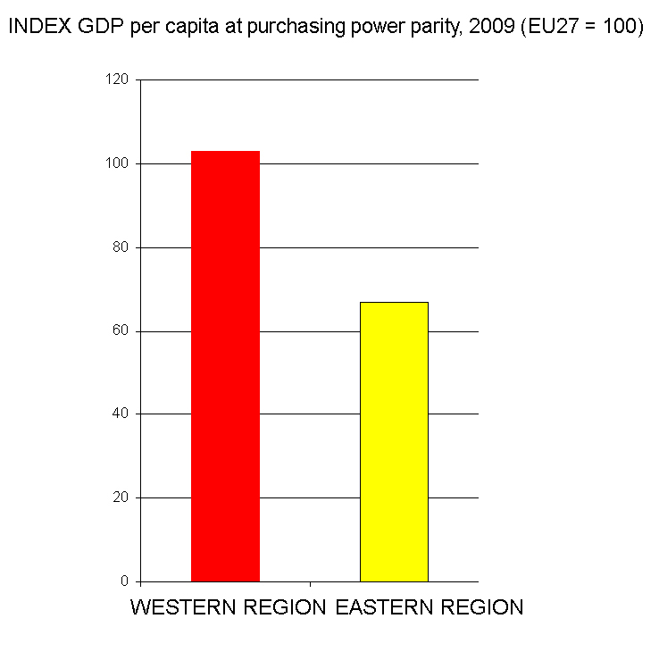
Undoubtedly, there are many reasons for dissatisfaction. We are not equally affected by the crisis. It is not by chance that Maribor was the first to go up in flames. Last week, we negotiated on the EU's seven-year budget till 2020 in Brussels. Europe was able to see our unenviable development discrepancies. The East Cohesion Region with Maribor stands at 73% of the EU average, while the West Cohesion Region with Ljubljana makes 106%. The standard of living in the east is one-third of that in the west, which can be also seen in the number of the unemployed. Irrespective of this, as much as 60% of the total aid granted by our state in the last year went to Ljubljana region, which is by far the most developed region, while the remaining 11 statistical regions of Slovenia received 40%. The situation was not much better in previous years either.

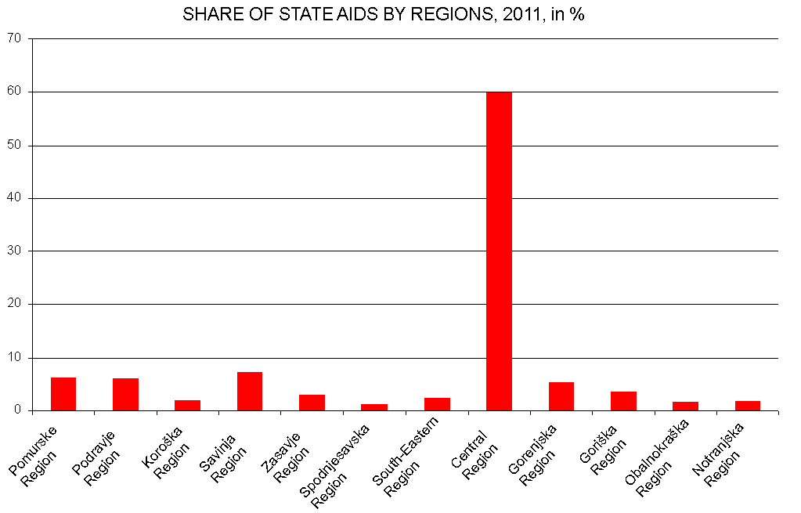

Is this fair? I strongly doubt it. Has Slovenian public even noticed this? Has Maribor noticed this? No, as a matter of fact, because for some years now the media attention has been focused on the false statement made by the Mayor of Ljubljana alleging that the State had unjustifiably taken 60 million from him.

Accelerated development of all regions, in particular the eastern part of the country, is therefore one of the urgent tasks to be undertaken in Slovenia by the end of this decade. This will be one of our priorities in our negotiations on the European development funds.

Demands calling for a just state are greatly justified. It cannot be right that a person who allegedly cheats in German language exam is punished, while the international criminals caught in dealing with hundreds of kilograms of cocaine are cleared of charges. It cannot be right that a person who abuses a business credit card in the amount of EUR 40 is held responsible, while those who stole millions of euros from Slovenian banks walk unpunished and preach about the economy and morality. The bad bank act envisages a four-fold extension of the period of limitation for these crimes. This is also a basic motive followed by a part of politics and background players in blocking this Act.

Some people say that the functioning of the judiciary must not be commented on. Nothing can be further from the truth. How are we to change matters for the better if we are not even allowed to discuss them? Discussion is urgently needed. It must lead not only to the functioning and respect for the rule of law but also to a just state.

However, this discussion should not get down the path of violence or disrespect for existing law and judicial decisions. We may consider a law unjust and we may oppose it, but we must comply with it as long as it is in force. We may see a court decision as unjust, we may also comment it as such, but we must comply with it and implement it. Any act and judgment can only be changed by other act and it is the task of the legislative and judicial authorities to enable an everyman, regardless of his status, equal access to the redress instruments.

At a time when important decisions are being blocked and when the historically low voter turnout in the first round of the presidential elections reached less than 50%, the discussion on the people’s confidence in politics is not only legitimate but also urgent. It must lead to changes – also to constitutional changes – which will enable that no mandate, neither in the legislative branch of power, nor in the executive and judicial branches of power, will be a blank note for non-performance, self-will or abuse of authority.

There is, however, no doubt that in democracy every individual who has exposed his name publicly on the ballot paper or in the election campaign and has been democratically elected anywhere in the country, be it a deputy of a coalition party or of the opposition, a mayor or a member of the city council, has a stronger constitutional legitimacy than someone who creates an anonymous website and calls to violence or someone who, wearing a mask, throws granite cubes and explosives at the police. If we allow this boundary to be erased, soon democracy will turn into dictatorship. Even more, we will again make the right to homeland subject to violence.

As for the government, its term of office is not protected as is the term of office of the President, a judge or a mayor. The government is constantly exposed to the public scrutiny. In the past two decades there have been eight changes of the government. Three times the government collapsed during its term of office. The initiation of the procedure for the vote of no confidence only requires signatures of 10 deputies. And an alternative majority. However, as long as these conditions are not fulfilled, the resignation of any government in the given situation would be an irresponsible act that would only further deepen the risk of chaos.

The constitution of the independent and democratic state of Slovenia stipulates that the right of peaceful assembly and public meeting shall be guaranteed. We are all obliged to respect and defend this right. The Government is certainly determined to do so.

Slovenia's democracy, independence and national identity are directly connected to peaceful assembly, but also to decisive protests. During the Slovenian Spring, ten thousands of people gathered on the roads and squares several times. This was even the case at the time when the tanks of the Yugoslav Army were positioned on the other side and when peaceful assembly posed a high level of personal risk. But all these protests – despite the specific demands that have determined the destiny of every one of us – took place peacefully and the protesters acted courageously and with dignity. Without any form of violence. No stone was thrown at the police, no window was broken. Nobody was hurt, neither any protester nor a police officer. We attended the meeting to fight FOR our goals and positive emotions prevailed. Positive energy helped us achieve more than any kind of violence could.

Every individual who decided at that time and is deciding today to join a public meting and protest in a peaceful manner with the aim of achieving positive changes in society, deserves every recognition as an active citizen. And in the present time we need active citizens as much as we needed them twenty years ago. Only in this way will we be able to accumulate sufficient energy to undertake some urgent changes. Like twenty years ago, also today every active citizen wishes that violence would not prevent these changes. I therefore firmly believe that also in the future the Slovenian Police will make every effort to protect peaceful gatherings and protests and that our active citizens and the police will jointly prevent violent individuals who are supported from the background to lead the country towards chaos.

Since the declaration of our independence we have witnessed many protest meetings organised by trade unions, interest groups and others. They took place in a peaceful manner, without violence, with a single exception, when a group of rioters mixed among student protesters and damaged the Parliament building. At that time, the entire Slovenian public condemned the violence and we believed that something like that would never happen again.

However, the protests on Monday in Maribor that started in a peaceful manner, turned similarly into severe violence. Protesters and police officers were hurt, public and private properties were damaged. In Maribor there was much more damage than during the student protests outside the Parliament. And today, those who condemned the students at that time, justify violence with the excuse that there was no other way and that all other means have already been exhausted. But have they? How come that suddenly such obvious double standards apply?

The objective does not justify the means. Acceptance of this thesis implies the twilight of civilisation. In our history, we, the people of Slovenia, have lived through a tragic period when lawless violence usurped the homeland right and ever since our soil has been covered with over 600 mass graves of illegally killed people. Is the present justification of violence rooted in this historical trauma? In declaring the mass killings a second-rate topic? If yes, then it is high time we became aware that we are slipping towards the edge of a new social abyss. We must therefore do everything in our power to keep our generations from repeating the mistakes of their fathers. Calling to violence, justifying the violence, inflammatory bias in reporting and commenting are not actions that will help calm down the situation. Actions to alleviate the situation do not include calls to gatherings knowing that on the very next website, somebody else is encouraging the participants to bring Molotov cocktails, explosives and granite cubes to this same gathering. We must hold our horses and not go beyond this point, because we know in advance what may happen. All who engage in this kind of activities are assuming immediate responsibility for potential tragic consequences of such explosive social fabric.

Some people wanted to donate clocks to the Government, hinting that its time is over. Perhaps they should themselves take the first look at the clocks. This Government took the oath of office only this February and nobody can expect that trends can be completely reversed in this period. Things will not get right by tomorrow either. Too little was done during the first three years of crisis; moreover, we doubled our public debt. Further borrowing today is possible only to pay off old loans, and even such borrowing is difficult to obtain. A sobering lesson in the shape of a change of the government was urgent and I believe that it was still on time. As early as in the first months of its term of office, the new Government adopted all the most important measures to overcome the crisis and increase the long-term competitiveness of Slovenia and, in consequence, our common prosperity. What we are doing is leading us out of the crisis, but it must be implemented in practice as well. Blocking through referendum initiatives, broken promises of the opposition parties, and now the violence in the streets, just escalates the crisis. For six months now we have been waiting in vain for a positive answer to the cooperation proposal we offered to the opposition parties within the Partnership for Development. The entire political sphere, as well as the general one, needs to sober up. We cannot spend more than we generate.

We all believe the news which tell us that foreign and domestic investors are fleeing Greece because of the blockades and violence in the Greek streets. And what is the message of riots, destruction and violence in Maribor and Ljubljana streets that are broadcast by foreign television networks? The already difficult persuasion of investors to invest in Slovenia and open up new jobs is becoming a mission impossible. The most affected will again be those who search for work in vain and young people who are finishing their studies and facing unemployment.

We are in a serious situation, but there is no need to give up. We have all the potentials to exit the crisis on our own. After long centuries we are now masters on our own land. The funds granted to us from the European budget considerably exceed our contributions to this same budget. Our future depends on us alone. There is no external enemy. We have to find an arrangement by ourselves. Successful negotiations on the pension reform and unanimous adoption of the respective law in the second reading should also serve as an example for future similar steps to be taken.

Dear Fellow Citizens!

We, Slovenians, have already proven several times that we can join our forces when faced with serious situations and that we are not naïve. If many of us believed after the first round of the presidential elections that it was not worthwhile to attend the second round because there was no choice, the circumstances have now changed completely. We will attend the presidential elections not only to support one of the candidates, but also to cast a vote in favour of changes and against the violence. That is, against the violence and chaos which are the worst enemies of freedom and justice, for it is about freedom and justice, for the freedom brought by the independence and democratisation of Slovenia – and for the promise of justice which we will not allow to be taken from us. We want to live in an independent, free and just state of the Slovenian nation, free of political uncles, free of fear and free of violence.

